NAME:VENKATRAMAMOORTHY.G
- Style an HTML snippet using different CSS selectors
- Inline CSS
- Internal CSS
- External CSS
CODE:
<!DOCTYPE html>
<html lang="en">
<head>
<meta charset="UTF-8">
<meta name="viewport" content="width=device-width, initial-scale=1.0">
<title>Document</title>
<link rel="stylesheet" href="style.css">
<style>
.font{
color:blueviolet;
text-align: justify;
}
#h1{
text-align: center;
}
</style>
</head>
<body style="background-color: aquamarine;">
<h1 class="font" id="h1">WELCOME TO CSS</h1>
<hr>
<div>
<P class="font">US President Donald Trump on Wednesday blamed Israel for the attack on Iran’s key offshore natural gas field of South Pars and claimed that the United States “knew nothing about this particular attack”.</P>
</div>
</body>
</html>

OUTPUT:
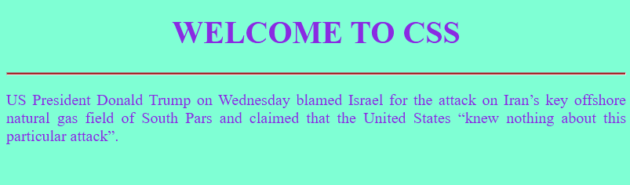

- Write CSS in styles.css to meet the following requirements:
- Use an element selector to
- Set all <p> elements' font color to #555 and line-height to 1.6.
- Use a class selector for .intro to: Set the font-style to italic. Use a class selector for .highlight to: Set background color to #f0f8ff and padding to 8px. Use an ID selector for #header to: Set text color to #2c3e50 and font-size to 32px. Add any additional style to the .box class to: Add a border of 1px solid #ccc and padding of 16px.
Link:[ https://github.com/GVRaman17/task/tree/cf4c83eaa8d7ef09759eb3d5e085033a7a28c610/19-03-2026%20CSS%20task-8 ]
OUTPUT:
